A STEP BY STEP GUIDE REGISTRATION GUIDE FOR PLAY FOOTABALL.
STEP 1:  Go to the Play Football website - www.playfootball.com.au  Select one of the 3 options shown. It doesn’t matter which one as you’ll be taken to the same page. | 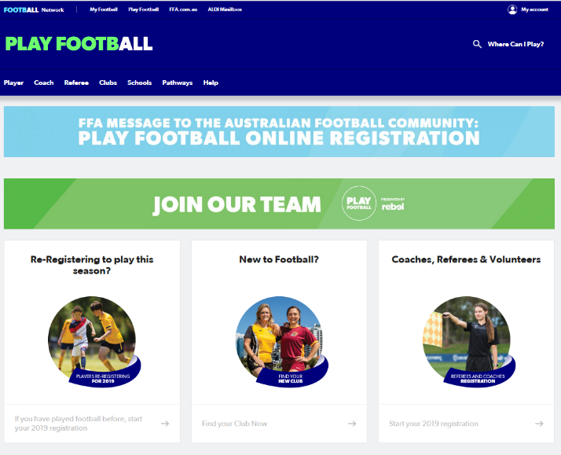
STEP 2:  Select the appropriate age group option. | 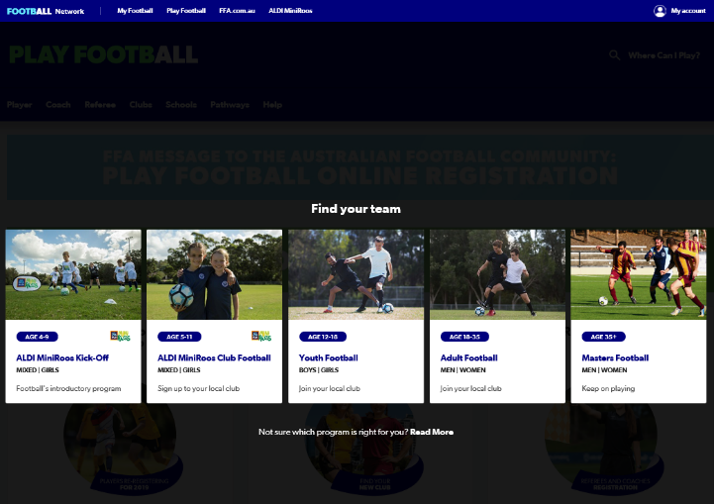
STEP 3:  Enter the Clubs Post Code – 6065 and select “Olympic Kingsway Soccer Club”. | 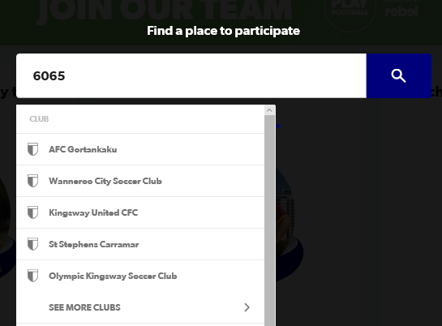

STEP 4.  Select the ‘START MY REGISTRATION’ button. | 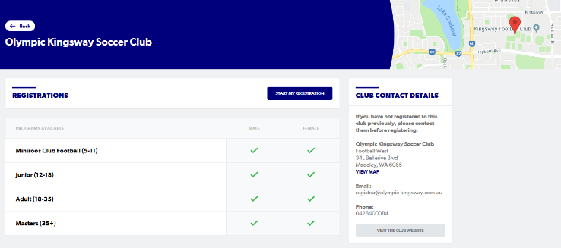
STEP 5.  This page shows you an entire list of all the registration packages if you scroll down. It is information only. There are also 3 fields to filter the package information. Ignore this and select the “Get started” button. | 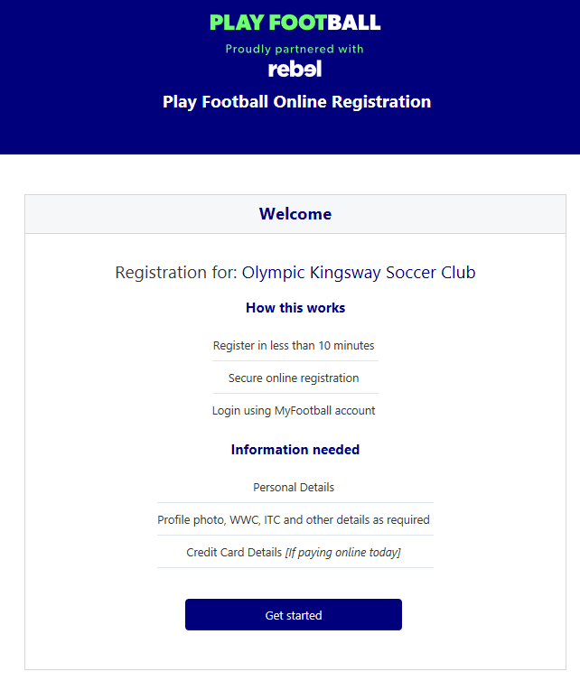  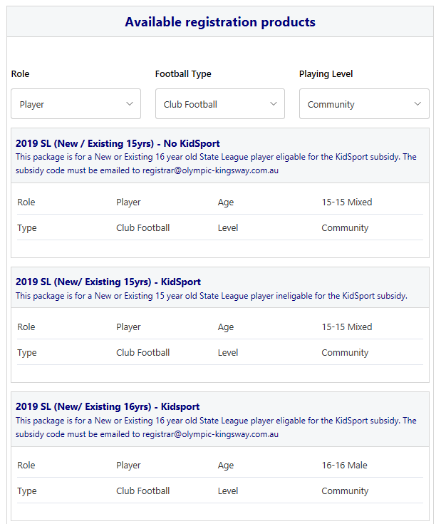
STEP 6:  This is an important part for parents whose children are under 18 years of age this year and if you have not created an account in this system yet. *Please note this system was introduced this year and 99.9% of people need to create a new account. So please read “BEFORE CREATING YOUR FOOTBALL ACCOUNT” information shown in the light blue box bellow and choose carefully!!! | 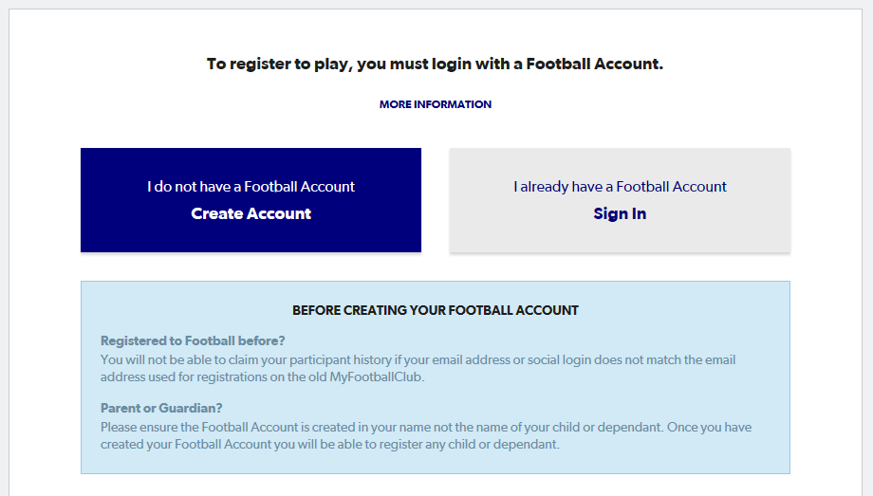
STEP 7:  You are now creating a Parent account. Therefore, this should/ must be your details and not your child’s.  After entering you details at the bottom of this page select “I have read and accept the terms and conditions, then press Register. You will be emailed a code to confirm the account is created. | 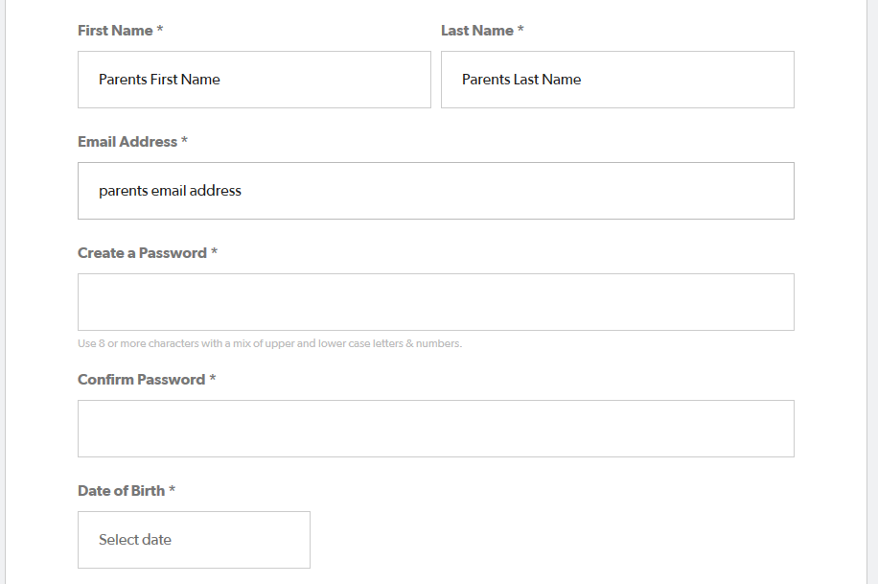  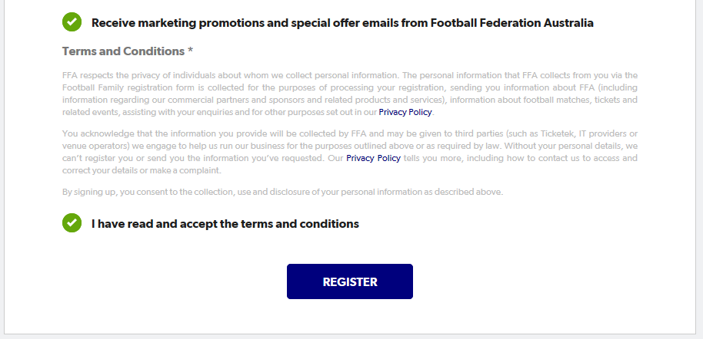
STEP 8.  Enter the code and you should be taken to this page, where you select the person you are registering. Select “I am registering a new person” and the type of person. i.e. CHILD. Then click continue. | 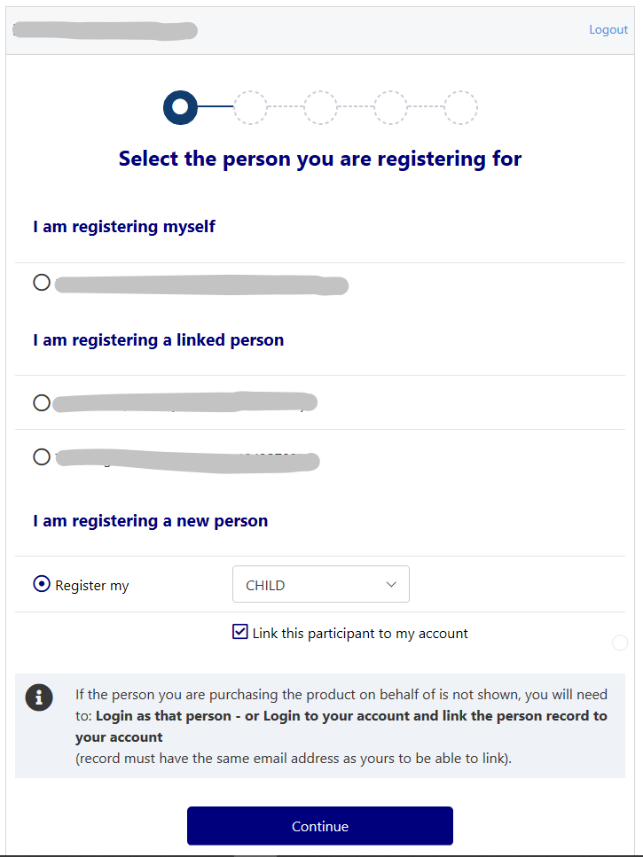
STEP 9.  Now enter your child’s details.  *NB: if your child played last year enter their first & last names, DOB and the email address used to register them last year to search for their FFA number. If you’ve changed your email address the system will not find the FFA# and playing history. Instead it will create a new FFA#.  Product Select: should be - Player/ Club Football/ Community in the drop downs.  Scroll through the list below and select the correct fee package and Team Preference. | 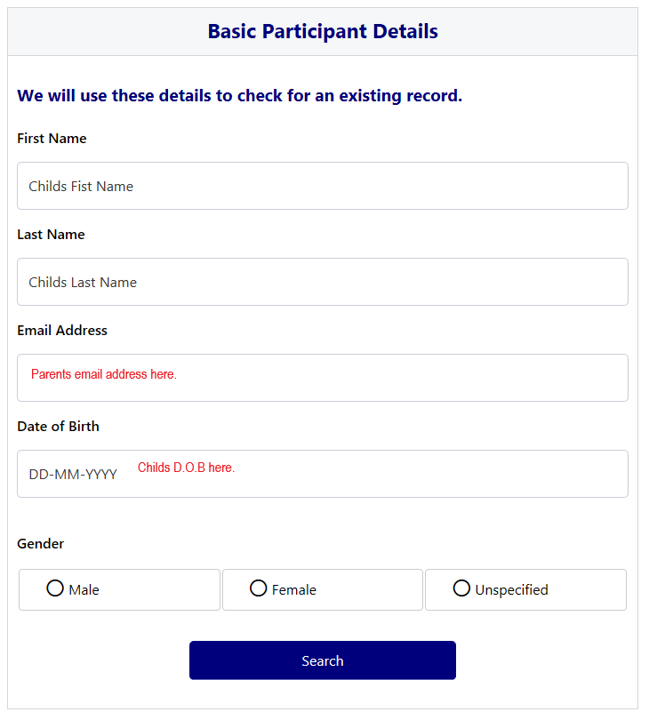  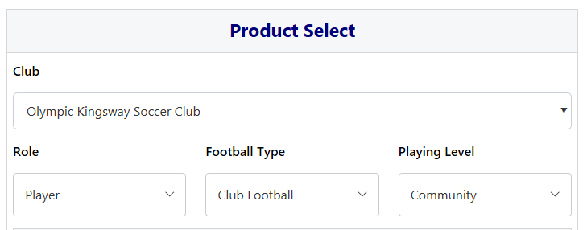
This image is an example.  The juniors Team Preferences will show a list of age groups (i.e. U6, U7, U8, etc.) | 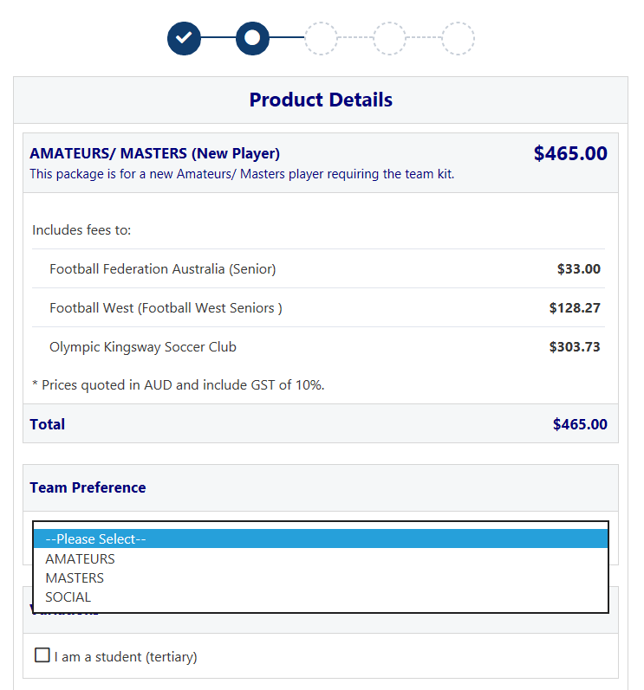
Next; Enter your child’s details here, including emergency contact information. | 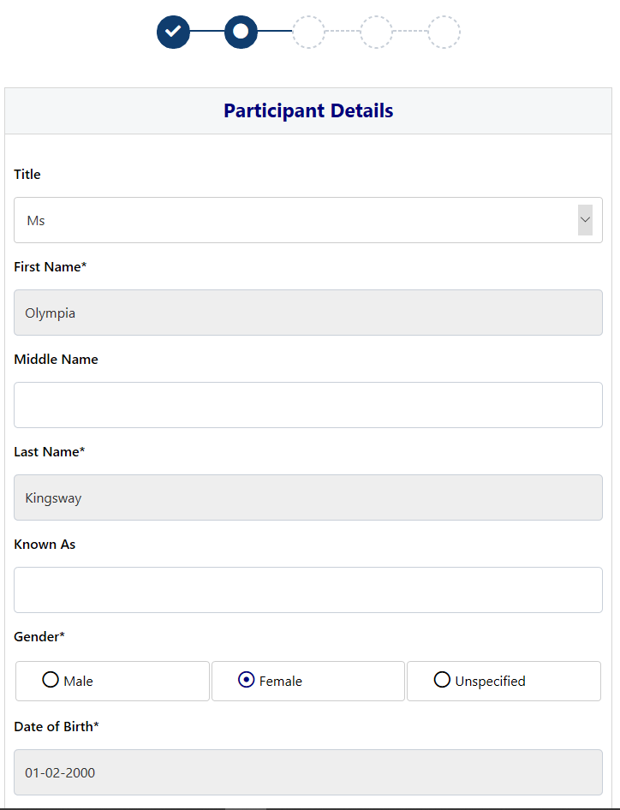
STEP 10.  A Profile Photo must be uploaded here or you cannot proceed. | 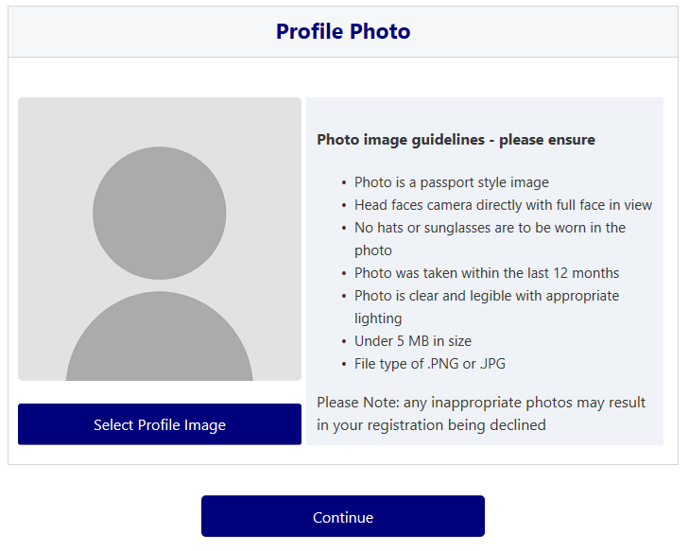  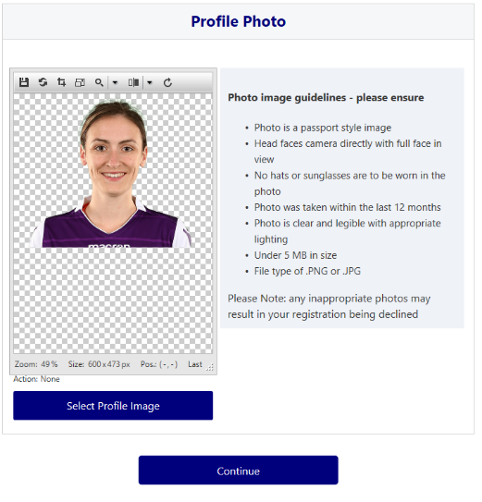
STEP 11.  Almost there. Choose the correct option in this drop-down and press continue. | 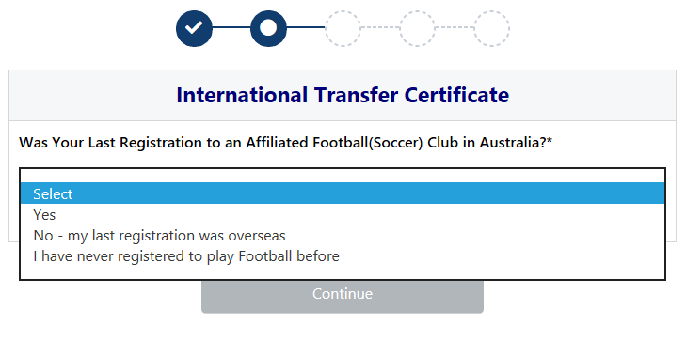
STEP 12.  Review your order, making sure all the information provided is correct. | 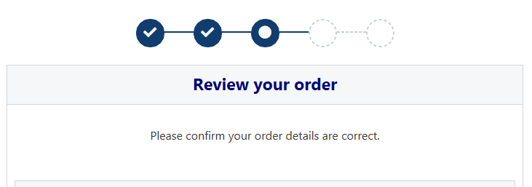  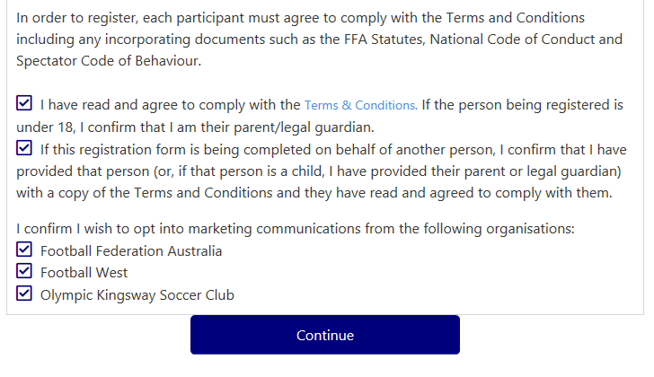
STEP 13.  *NB: If you have selected a KidSport package. Do Not select KidSport in the Voucher/ Coupons list and Do Not enter the code you have been provided. Unfortunately, this is currently a glitch in the system. Instead please email the KidSport code to registrar@olympic-kingsway.com.au  Either Pay Online through this Play Football registration system;  Or, Pay Offline via bank transfer to the club account. Ensuring that you add the FF# and Surname for the bookkeeper to reconcile the payment and validate the registration. | 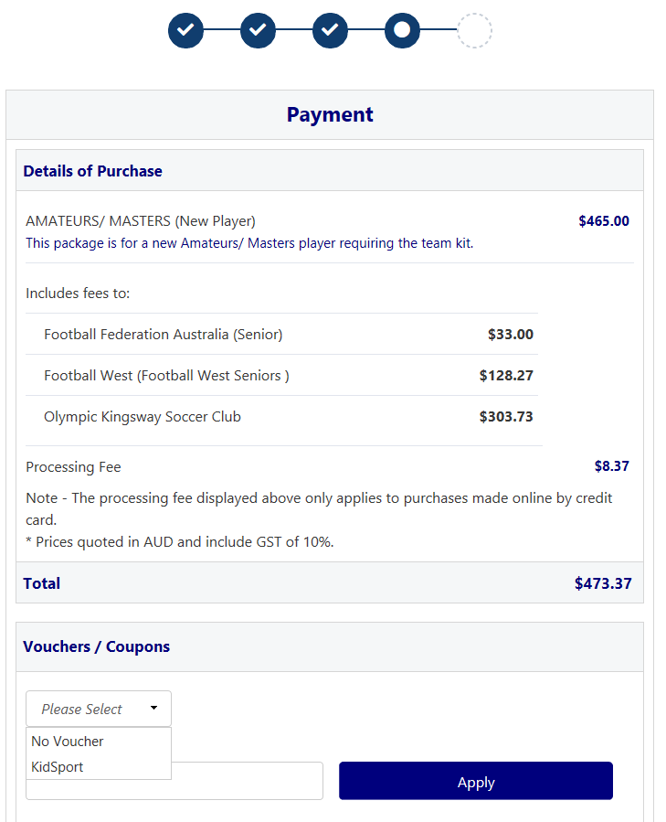  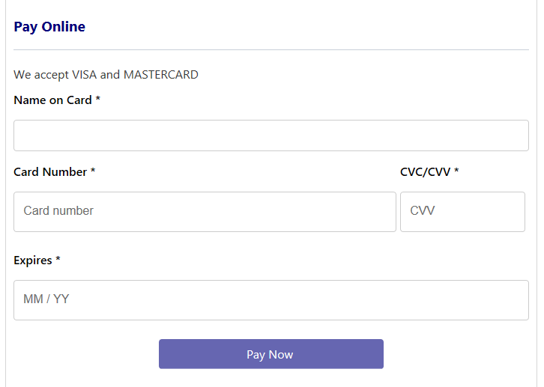  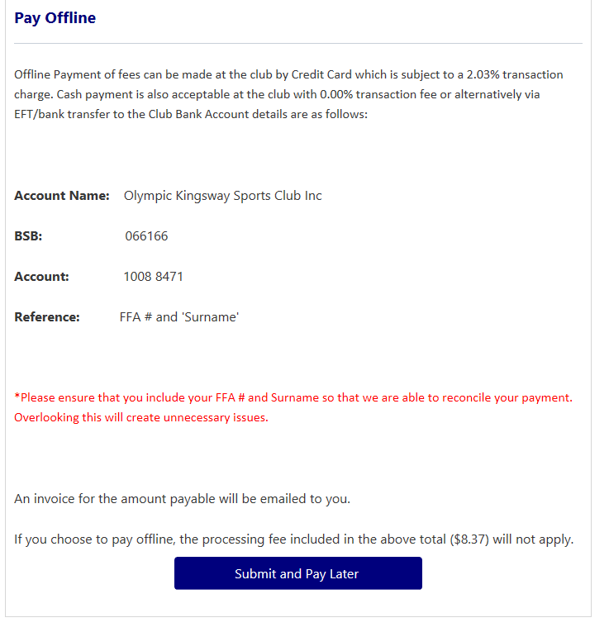
Once completed you will receive an invoice or confirmation via e-mail. | 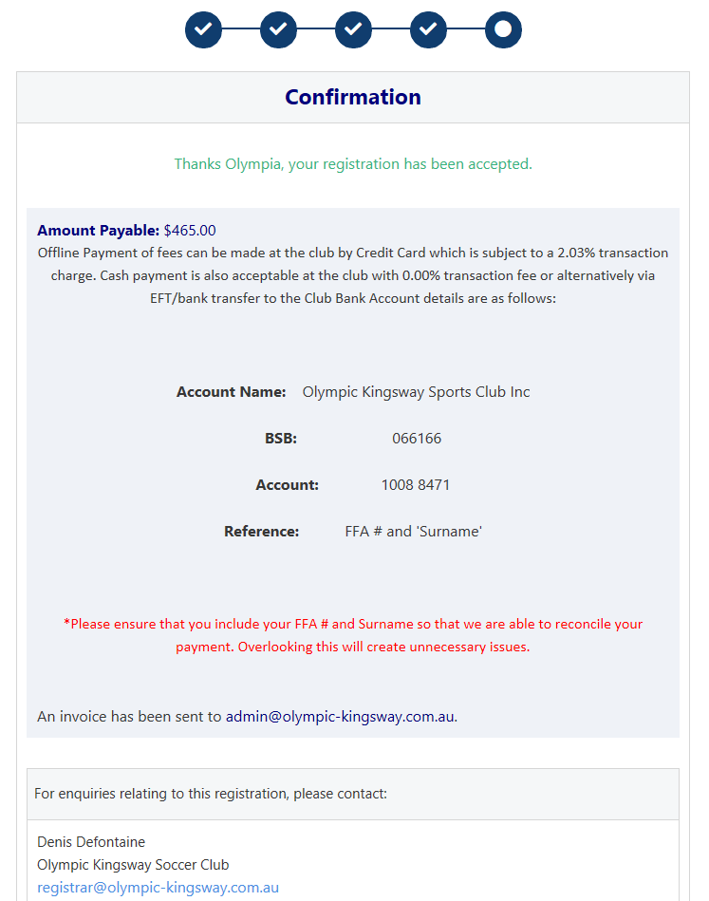

Done!

